**Extending the Functionality of On-line PD Monitoring Equipment for MV Power Cables**

You can’t put thermometers around every corner because of the sheer amount of MV cables. Signal speed can be used to monitor mean temperature along a cable segment. This is cheap and easily implemented, since PD detection units are already in place. PILC and XLPE cables are tested in a lab. Signal propagation speed is measured at different temperatures. Relative permittivity is measured using a network analyser.

An in-field 1464 metre PILC cable is monitored. The propagation time follows the load curve. This is consistent with lab results. The relation is approximately linear. 0.2 % variation in propagation speed corresponds to 5 °C temperature variation.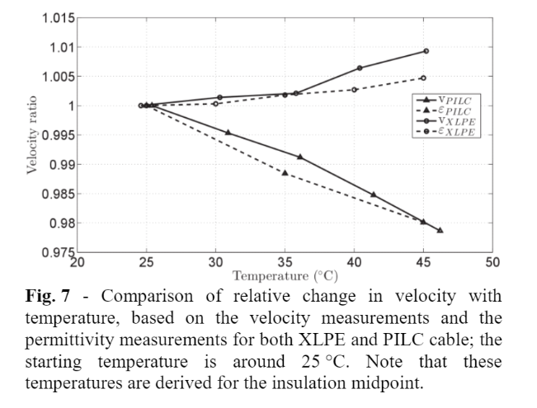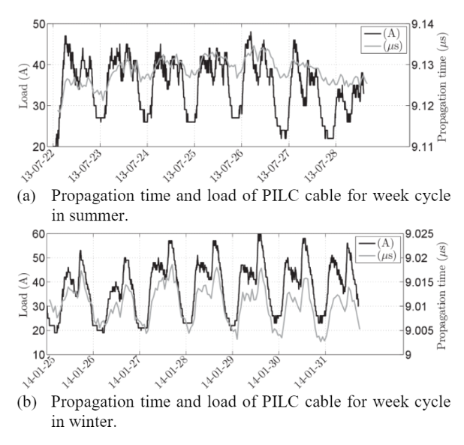

**Guarding MV Cables On-line: with Travelling Wave based Temperature Monitoring, Fault Location, PD Location and PD related Remaining Life Aspects**

HV cables use real-time temperature measurement, but this is too expensive and extensive for MV cables. The same lab setup is used. Speed is derived from permittivity using the formula:

$v=\frac{1}{\sqrt{ε_{0}ε_{r}μ_{0}}}$

A 1 % speed drop corresponds to a 10 °C temperature rise for PILC. A 1.2 kilometre PILC cable is monitored. A transit time of 7.5 μs and sample rate of 50 MHz give a time resolution of 0.3 %. The resolution can be increased by taking the average of 60 signals over 1 hour.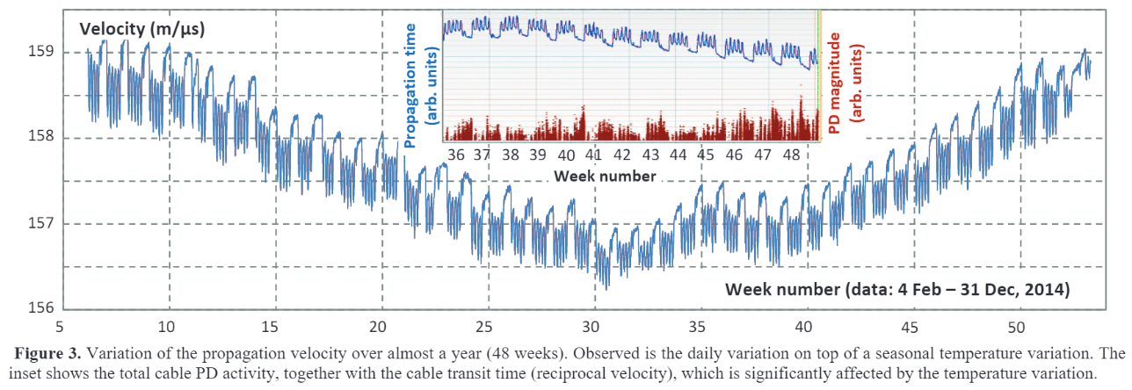

Seasonal effects and the 5-day working week cycles are clearly present. Daily speed variation is about 0.3 %, corresponding to a 3 °C temperature fluctuation. Yearly speed variation is about 1.2 %, corresponding to a 12 °C temperature fluctuation. Despite the small daily variation, PDs clearly increase in frequency and magnitude with changing temperature. This seems to coincide with the *cooling down* period.